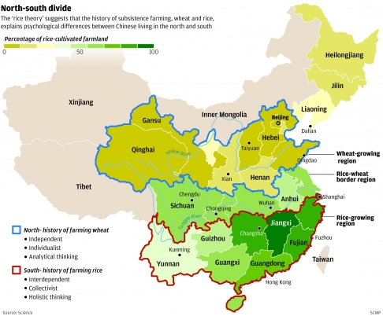

Question: The question that will be addressed in this project is this: Between a univariate model (only wheat production) and a bivariate model (GDP per capita as the explanatory variable and wheat production as the response variable), which one will better predict future Chinese wheat production?

STAT 153 Project – Predict Future Wheat Production

Keun Gang Kyen (#23983641)

Statistics 153: Time Series

Professor Brillinger